High energy prices not a ‘one-winter deal’, says BP boss

Bernard Looney warns current crisis is unpredictable and is something that could be with us for some time
Expand
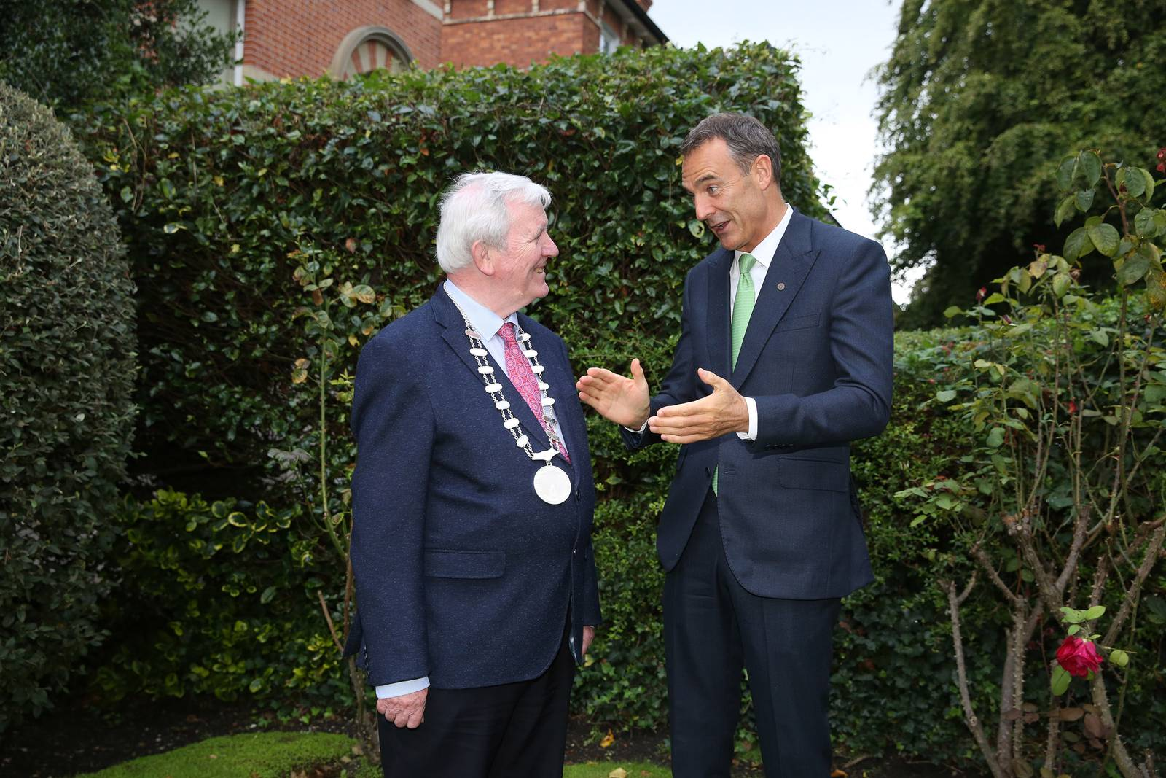
BP chief executive Bernard Looney (right) with Tom Leahy, president of the Irish Academy of Engineering, which inducted the Kerry native as a fellow on Monday. Photograph: Maxwells
Barry O'Halloran
Tue Sep 6 2022 - 05:15
The global crisis that has sent Irish energy prices soaring is not a “one-winter deal”, Bernard Looney, chief executive of oil giant BP warned on Monday.
Leading Irish energy suppliers announced price increases last week set to add hundreds of euro to household bills as Russia halted gas exports to Europe indefinitely.
“This is not a one-winter deal, this is something that seems to be with us for some time,” Mr Looney told the Irish Academy of Engineering.
He warned that many elements of the crisis were difficult to predict and advised that any action taken to deal with it should assume it could last for years.
Some figures estimate that Irish homes could end up paying more than €4,000 a year for energy following the latest round of price increases, a response to surging wholesale charges, which are in turn driven by the cost of natural gas.
Mr Looney was speaking after the Irish Academy of Engineering inducted him as a fellow in recognition of his achievements.
A native of Kenmare, Co Kerry, where he grew up on a small farm, Mr Looney graduated as an electrical engineer from UCD in 1991. He then went straight to work for BP as a drilling engineer in the North Sea.
He subsequently worked on the discovery of the Thunder Horse field, the Gulf of Mexico’s biggest deepwater reserve, which holds about one billion barrels of oil and is jointly operated by BP and ExxonMobil.
While working for BP in North America, he joined the Sloane business programme at Stanford University in the United States, graduating from there in 2005. He then spent two years as the group’s vice-president, Alaska.
Mr Looney subsequently returned to Europe where he held various positions before becoming chief executive in February 2020, a month before the Covid-19 pandemic shut down most countries.
BP aims to be “zero carbon” by 2050, and is investing heavily in renewable technology, including wind energy, hydrogen, sustainable aviation fuel development and electric vehicle charging.
He pointed out that BP’s biggest integrated offshore project was a plan to develop wind farms around Britain’s coast capable of supplying electricity to six million homes.
However, the energy giant chief stressed that the company would continue to invest in hydrocarbons – fossil fuel – through this decade, as they were needed to aid the ultimate transition to renewable power.
Mr Looney said his industry faced “trilemma”, a three-way question of how to supply provide secure, affordable and sustainable energy.
He argued that the answer to the question was not to favour one technology over another, but to integrate them. “There is no one solution,” Mr Looney counselled.
“If we have learned one thing in the last while, it’s that energy really is our lifeblood,” he said.
Irish Times 6th September 2022

