‘We are putting our money where our mouth is’: BP chief Looney defends vow to be net zero by 2050
The Co Kerry native, one of the most powerful corporate executives in the world, has instigated a major restructuring of the oil and gas giant since taking over as chief executive two years ago
- LORCAN ALLEN

- SEPTEMBER 10, 2022
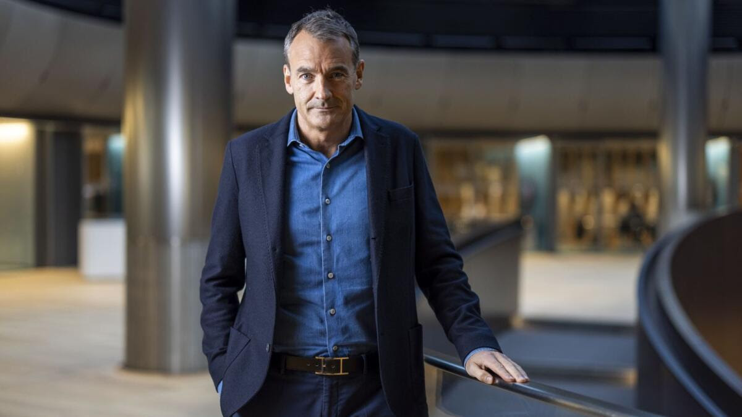Bernard Looney, chief executive of BP: ‘We will no longer be an international oil company. We will be an integrated energy company.’ Picture: Bloomberg
Bernard Looney, the chief executive of BP, has defended his company’s pledge to be net zero by 2050.
“We are now, uniquely we believe, the only major oil and gas company aiming to be net zero, across operations, production, and the energy products we trade and sell,” the Irishman said of the €100 billion British oil and gas giant.
“Critics will say that is just greenwashing. But we are putting our money where our mouth is. In 2019, just 3 per cent of our capital investment was in low carbon. In 2021, that figure was up to 17 per cent and by 2025, which is just three years away, we are aiming for over 40 per cent of our capital going into non-hydrocarbon businesses. We believe it will be over 50 per cent by 2030.”
The Kerry native, who joined BP as a graduate in 1991 and became its chief executive in February 2020, was speaking in Dublin last week at an event in which he was formally inducted as a fellow of the Irish Academy of Engineering.
Despite being one of the most powerful corporate executives in the world, the 52-year-old is not a household name in Ireland, having spent almost all of his career working in far-flung parts of the world in the oil and gas industry.
The event provided a rare opportunity to hear the story of a remarkable business career, but it also allowed the audience to question a man who works for a company that accounts for a significant share of the world’s carbon emissions.
Since taking over as head of BP, he has instigated a major restructuring of the company in a bid to transition the firm into a renewable, clean energy provider.
“The strategy of the company is to transform ourselves. We will no longer be an international oil company. We will be an integrated energy company,” he said.
“An integrated energy company is one that knits together different kinds of energy into a simple solution for customers.”
He added that the world was facing what he called the “energy trilemma” to provide secure, affordable and low-carbon energy.
BP, which was fined more than $20 billion for the 2010 Deepwater Horizon oil spill that killed 11 men and spilled three million barrels of oil into the Gulf of Mexico, is one of the world’s seven oil and gas "supermajors".
The company operates in 65 different countries and employs 65,900 people around the world. In 2021, BP produced 1.85 million barrels of oil per day but Looney said the company is shifting its investments into renewable energy.
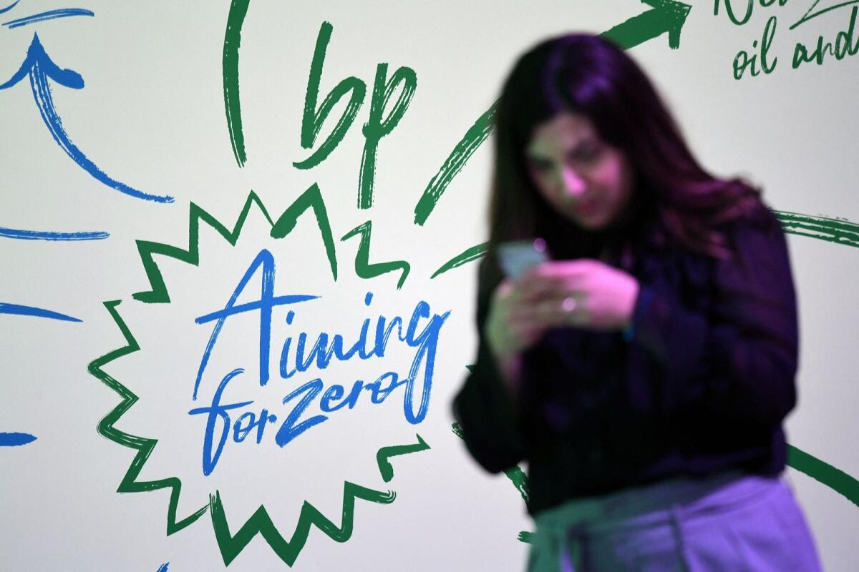
BP’s ‘Aiming for Zero’ campaign hopes to see the company produce net zero carbon emissions within the next three decades. Picture: Getty Photo by DANIEL LEAL
“We have a worldwide cost of living crunch. We have a war in Ukraine. And, of course, we have the energy transition. These, taken together, have intensified what I describe as the energy trilemma, which is that desperate need the world has for energy that is more secure, more affordable, and lower-carbon,” he said.
“When I took on this job in 2020, it was with the conviction that to help solve the energy trilemma, BP had to change. And this was the result of months of listening and engaging with BP employees, with climate experts, with academics, with NGOs, and with activists who are pretty fierce critics of BP.”
Looney said that these conversations led to BP’s commitment to being net zero by 2050.
When asked whether he sees a role for carbon capture solutions, which is an emerging technology where companies pump carbon back into the empty oil and gas fields from which they previously extracted fossil fuels, he said it had to be a solution to the climate crisis.
“Carbon capture and storage is like fracking, in that it evokes an emotional response from some people. The reality is, if we’re going to solve the energy trilemma, we’re going to need all the solutions. And carbon capture is going to be one of those solutions,” he said.
“Carbon capture plays very well to a company’s strengths like ours, because we’ve spent decades taking carbon out of the ground. And what we would be doing here is capturing it and putting it back in the ground, so we would know how to do that.”
Looney said that the company was working on a major €14 billion project in Britain right now to test this technology at scale.
“We’re establishing a massive industrial cluster at Teesside, where something like 50 per cent of the industrial cluster emissions in Britain are in this one area. We’re going to create the infrastructure that will become the host for businesses and industries in that area,” he said.
“We’re going to build a pipeline, drill wells, and create a carbon capture system. And then the government will incentivise industry and businesses in that area to capture their carbon [emissions] and we will provide the mechanism for them to then transport it offshore and to pump it underground.”
Although much of the focus at the Irish Academy of Engineering event was on Looney’s view of the potential for medium- to longer-term solutions to climate change, the BP boss was also asked about his views on the current energy crisis in Europe.
Large oil and gas companies like BP have drawn considerable criticism already this year as they all reported record sales and profits on the back of surging energy prices. Last month, BP reported bumper second quarter earnings as underlying profits in the business surged 35 per cent to $8.5 billion.
On the back of the bumper results, the London-headquartered company increased its interim dividend to shareholders by 10 per cent to $0.06 a share, and committed to buying back $3.5 billion worth of shares from investors in the third quarter after completing $2.5 billion of buybacks between April and July.
When asked if the company would consider cutting its fuel prices in the face of a growing cost of living crisis in Europe, Looney said the company would maintain its prices. He added that it was up to individual governments to introduce windfall taxes or levies on the oil and gas industry.
Looney said that Russia’s invasion of Ukraine had caused major disruption to European energy markets, and that he expected the current price inflation for energy to last multiple years.
“This [energy crisis] is not a one-winter deal. This is something that seems to be with us for some time,” he said.
“Someone once told me, if you have an unsolvable problem, make it harder to solve. And the point is that you almost have to assume that [the current energy crisis] is going to go on for years, even if we don’t know. What we have to be very careful of is hoping it won’t.
“If you make the problem bigger and assume it will go on for years, what actions would you take? And those actions can be very painful in the moment, but they can be very valuable in the months to come. And every day you wait, you delay the future.”
Born in 1970, Looney grew up on a 90-acre dairy farm in Co Kerry, which he says was instrumental in developing his interest in engineering.
“Growing up in our small farm just outside of Kenmare, we had a lot of challenges in the physical world, I can tell you. Anyone who has tried farming in that part of the world would know what I mean. I do not recommend it, especially if you’d like to make some money.
“I think we ticked off electrical, chemical, mechanical and civil engineering, sometimes all before we would milk the cows in the morning. We may not have had the qualifications at the time, but we certainly knew how to engineer the solutions.”
Looney went to UCD and graduated as an electrical engineer in 1991. He joined BP as a graduate straight out of college, and found himself posted to Britain’s North Sea as a drilling engineer. He went on to work on BP projects in the Gulf of Mexico, Alaska and Vietnam.
Business Post Article, 10th September 2022

